PP-2021-5619/EF21/13786

Mr Steve McGrath
General Manager
Coffs Harbour City Council
Locked Bag 155
COFFS HARBOUR NSW 2450]

Via email: marten.bouma@chcc.nsw.gov.au

Dear Marten

I am writing in response to your request for the Department’s approval as required by condition 2 of the Gateway determination, to the exhibition of PP-2021-5619 which has been updated in accordance with condition 1.

The planning proposal has satisfactorily addressed the issues raised in condition 1 of the Gateway determination and may now proceed to exhibition in accordance with condition 3.

Should you wish to discuss this matter further, please contact me on 5778 1487.

Yours sincerely

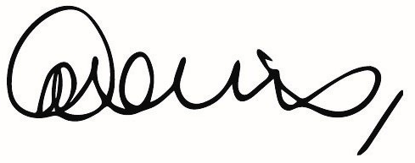

Gina Davis
Senior Planner
Northern Region

